AGENCY SCRIPT

Opener & Permission
Hi <Lead Name>? [hard stop]

Hey <Lead Name>. It's (Your Name). From Silveredge

I wonder if you could help me. I came across your company XYZ and wanna reach out. Can I get 30 seconds

[they reply]
[acknowledge their reply]

[hard stop]

Pitch 1
We are just hoping to introduce ourselves our company silveredge, so what we do is we help businesses like yours by calling executives on your behalf so you dont have to hire or manage inhouse callers, basically our team makes targeted calls and books meetings straight into your calendar, so you can focus on closing and hit your targets
Not sure if this is for you but, would you be opposed to a 20 - 30 min conversation sometime this week?

[let them respond]
[Insert Benefit pre warm for the invite]
Confident Close & Confirmation = capture interest, boost show rate
Great!
<offer for call>.

How does <day> <morning/afternoon> look to chat further?
By the way what time zone are you operating in

[let them respond]
I just pulled my calendar up. How does <time1> on <day1> or <time2> on <day2> work?

[let them respond]

Alright great, I’m going to send it over right now.

Is <email> the best place to send it?

[let them respond]

[send it]

By any chance do you happen to have access to your email or calendar?

[let them respond]

( If yes ) kindly click the accept button or were you able to receive it?

[let them respond]

Great, thanks! And in the event you won’t be able to make it, how will you let us know?

[let them respond]

Would it be okay if you can respond to our email? That way our team would be looped in

[let them respond]

Right on- I’m looking forward to it!

Talk to you soon <name>.

Handling Objections:  These are suggested rebuttals  FRAMEWORK  Maximum of one discovery question to confirm data  then benefit / reframe then invite  Careful not to ask alot of questions  Mindset is to sell the appointment  Not do discovery session on the call | Prospect: I'm not sure if we need this right now, we dont need this, its not needed.  I understand , though I'm just curious. What made you say that you don’t need it?  When you say not right now, is it because of the timing?  Question: How are you getting leads or new businesses right now?  Prospect: I'm not interested  Quick question, how are you getting new businesses ?  —---------  Prospect: I’m in a meeting  Oh, I’m sorry can I call back on a later time?  I'm not the right person.  Understood. But do you think our services would be a potential fit to the business? ( if yes, then ask who is the right person to contact, or ask for a recommendation )  Prospect: We’re still restructuring our business call me back in 4-6 months  But do you think cold calling is relevant to your business? I can call you back after a few months ( add to CRM )  Prospect: Send me an email.  I can send you an email but  We can put a place holder on your calendar after I send you an email and if you liked what you are seeing, you can attend the meeting, if not you can just decline  That way your questions get answered live and get real time feedback  Prospect: we already have someone  - oh that's wonderful, can I ask a question about it? If there is one thing you wish that your current provider would do or have, what would it be? Maybe a lower cost, a better this and that.  Prospect: This is my personal number  Oh, sorry about that. We cannot really identify if its a personal or a work phone  Prospect: How did you get my number  We actually got your number from public available sources and from our lead generation research team  Prospect: Are you selling me something / is this a sales call?  I'm actually here just to introduce ourselves  Prospect: Do you have experience in this “Specific” industry of mine  The good news is our skill is transferable to any industry, we do dedicate a product training day, for us to understand enough to book meetings for your business  Q: What makes you different?  A: thank you for that question, The best person to speak with is our outreach expert, and the reason for that is he has the full overview and knowledge both back end and front end, but what I can tell you from my experience in the front end,  I am able to speak with decision makers and our calls are targeted I am not really sure how our back end team does it but can i book you an appointment with our expert  Prospect: Cold calling doesnt work!  HavH  Have you tried cold calling before?  [ Wait for an answer]  I understand, every agency has its own approach and methodology, its like saying ads and other channel doesnt work because it didnt work for them,  Cold calling isnt dead, its just done badly by almost everyone else  Would you be curious to check our approach to cold calling? [invite for an appointment]  Prospect: We dont do outbound  so what's your current marketing efforts that you are doing right now?
Prospect: Whats your costing

it would ultimately depend on your requirements, targets campaign. And that conversation is up to you and my outreach expert to meet half way with a number.

If they persist

As much as I would love to give you a number, its actually our back end team who has the full knowledge of the pricing and process. And it would be best If i can set you up for a 20-30 minute conversation with no commitment just to see if there is a fit.

Our services starts at roughly 2,000- 10,000 a month

Prospect: I will only agree on a meeting if its a performance based.

Im not really the right person to decide on that, but as what I know. Our team is flexible when it comes to your requirements. it would be best If i can set you up for a 20-30 minute conversation with no commitment just to see if there is a fit.

Pricing Objection Rebuttal — "How much does it cost?

I'm not going to quote you a number, because any number I give you right now would be a guess. Pricing depends on your offer, your Average Contract Value, and how big your dialable market actually is. That's exactly what the call is for. My job is to get you in front of our outreach expert who can actually run those numbers with you. Thirty minutes, no pitch, and if it's not a fit you'll know on that call."

If they push: "Just give me a ballpark.
Here's why I won't, and it's not me dodging. Say I throw out $2,000 a month and your product sells for $5000. That math doesn't work for you. I'd rather tell you nothing than tell you something wrong. On the call we look at your economics first, then price it so it works for both sides.

The three pillars (Eric needs these memorized)
The AE has to identify these on discovery, and this is the reason the rebuttal holds up:
- Offer economics — nature of the business, pricing, ACV. Determines whether the quote makes sense for them.
- Total addressable market — how many dialable leads exist for their ICP. Determines campaign duration and feasibility.
- Targets — the specific number, negotiated between the prospect and the AE.

Where did you get my number? | Your number and company are publicly available from our research lead team  . (if they ask for more information Google, LinkedIn, and Facebook are all OK answers)
Where are you located | We are located in the Philippines, with a team of dedicated callers ready to assist you.
Website | www.yoursilveredge.com

Q: What are your KPI’s

We usually hit 1 meeting per shift after the ramp up -But the best person to discuss all these would be my account executive
- proceed to invite a meeting

SOP's & Non- negotiables
Call preparation

- Tech check every before start shift, use vocaroo to check audio and microphone
- Refrain from idleness and distractions like phones during shift
- Use built in live captions in windows or mac so you can also read what the prospect is saying

Trello CRM log

- Be sure to always add notes on the comment section for every interaction, label it and use due dates for follow up reminders
- If a lead is no longer working and has given you names or referral - send the lead name and website to slack so i can manually scrape and we call that lead.
- Do not dial other than -4 if its first half of the shift, or you will be dialing them at dawn

Email sending

- Every time a lead asks for an email or a potential callback/follow up
Add them unto the CRM -Email sent/ interested / callback
- Utilize GPT or Claude for email constructing - watch this video https://www.loom.com/share/bf3e9169e27544b88f1624f0ed0a1665
- Subject is “ Our approach to qualified appointments “
- 3 Pager to attach 3 PAGER

Hi [Name],

I really appreciate you taking a moment to answer, especially while you were in the middle of something.

I've attached our outbound strategy document, which outlines the approach we take for our cold calling services and how we help drive qualified opportunities.

Inside it you'll also find a link to a sample folder with an actual recording of one of our live cold calls, a real conversation, not a script read. It's the quickest way to hear how our team sounds on the phone and judge the quality for yourself before we ever speak.

I just thought it might be worthwhile to schedule a casual, no-obligation conversation with our outreach expert to learn more about your business and see whether there could be a fit.

Would a short 30-minute chat work sometime this week or next?

Follow-up and voicemail cadence

- Give the lead 24-72 hours window to follow up call or email as you think appropriate we do not want to come across as too aggressive
- On the 3rd and 4th call back have the follow up window up to 3-5 days as appropriate as you think same goes with the email
- Maximum of 4 callbacks total and leave a voicemails, together with 3 email cadence not same day from call backs

First call follow up attempt sample spiel
Hi [ Client ] its [ SDR ] from Silveredge, were you able to review our approach to qualified meetings document? And hopefully you were able to listen to our outreach call sample spiels inside
- No voicemail just an attempted call if no answer
- Then send the first email follow up

Second call follow up attempt sample spiel-
Circling back from our conversation the other day, were you able to review our approach to qualified meetings document?
- Leave a voicemail
- NO email
Third call follow up attempt -
- Leave a voicemail
- Leave the 2nd email

Fourth call follow up attempt
- Leave a voicemail
- Leave third email

1st email follow up sample ( reply on the same thread )

Circling back on the overview I sent through and wanted to check if you had a chance to look it over.

Happy to walk you through how that'd map to [Company]'s targets on a quick 20-30-min call. Would this week or next work better?

2nd email follow up sample [ new thread subject- Recordings from our outeach ]

Hi [First Name],
Sent an overview through a little while back and haven't heard back no worries, I know how inboxes get.
Attaching our 3-page outbound breakdown. There's a recording in there of one of our live cold calls, a real conversation, not a script read. Quickest way to hear how the team actually sounds before we ever speak.
Quick one so I'm not chasing unnecessarily: is this still worth exploring for [Company], or should I park it and check back next quarter?
Either's completely fine.
Attach 3 pager PDF again.

Third email follow up [ new thread subject- Should I close this out? ]

Have I lost you on improving [Company]'s outbound?
No pressure either way if the timing's off, I completely understand and I'll stop reaching out.
.
Follow-up and voicemail cadence ( reminder )

- Give the lead 24-72 hours window to follow up call or email as you think appropriate we do not want to come across as too aggressive
- On the 3rd and 4th call back have the follow up window up to 4-5 days as appropriate as you think same goes with the email
- Maximum of 4 callbacks total and leave a voicemails, together with 3 email cadence not same day from call backs

Pre-booked appointment day

- A day before the appointment day send an email for the lead every 1PM EDT
- CC: orven@yoursilveredge.com
- The highlighted words are the things you need to modify like the name, day and company
- If the meeting falls on monday send this on friday and change the highlighted as needed

Tomorrow's Call: XYZ CLIENT COMPANY

Hi Todd,

Quick heads up before tomorrow's Outbound Strategy call.

No pitch on the agenda, the goal is simply to understand your business and where things stand today. If there's not a fit, we won't force it, you'll know quickly either way.

You'll be speaking with Orven Mata, who'll walk you through what's possible for your business and put together a short summary of next steps afterward, aligned with your goals.

If anything comes up or you need to move things around, just let me know here. Otherwise, see you tomorrow.

Speak soon.

Non-Negotiables

- If ever you found a call that is worth informing me, like a call that needs escalation, an irate lead, or a call that is concerning, a call that you are unsure of or you are challenged. INFORM ME ASAP, I encourage open communication and feedback. As we are all learning, growing and collaborating.

- Intentional or malicious dropped calls: level 4-5 escalation or termination
- Arguing or being aggressive with leads level 4-5 escalation or termination

Disposition
Manual Call back - for follow up and call back
Appointment booked - Lead converted to booked appointment

NOT INTERESTED - You were able to go past opener but the lead is not interested in what we do

No pitch No price - Lead hanged up before opener or you werent able to get past opener

DISQ - wrong number, lead not qualified

AM - Answering machine, dead air, etc.

Becareful and be mindful for wrong disposition as we cannot change it
If that happens notify me asap

Booking Navigation
https://cal.com/yitzhak-orven-mata-8t4hbl
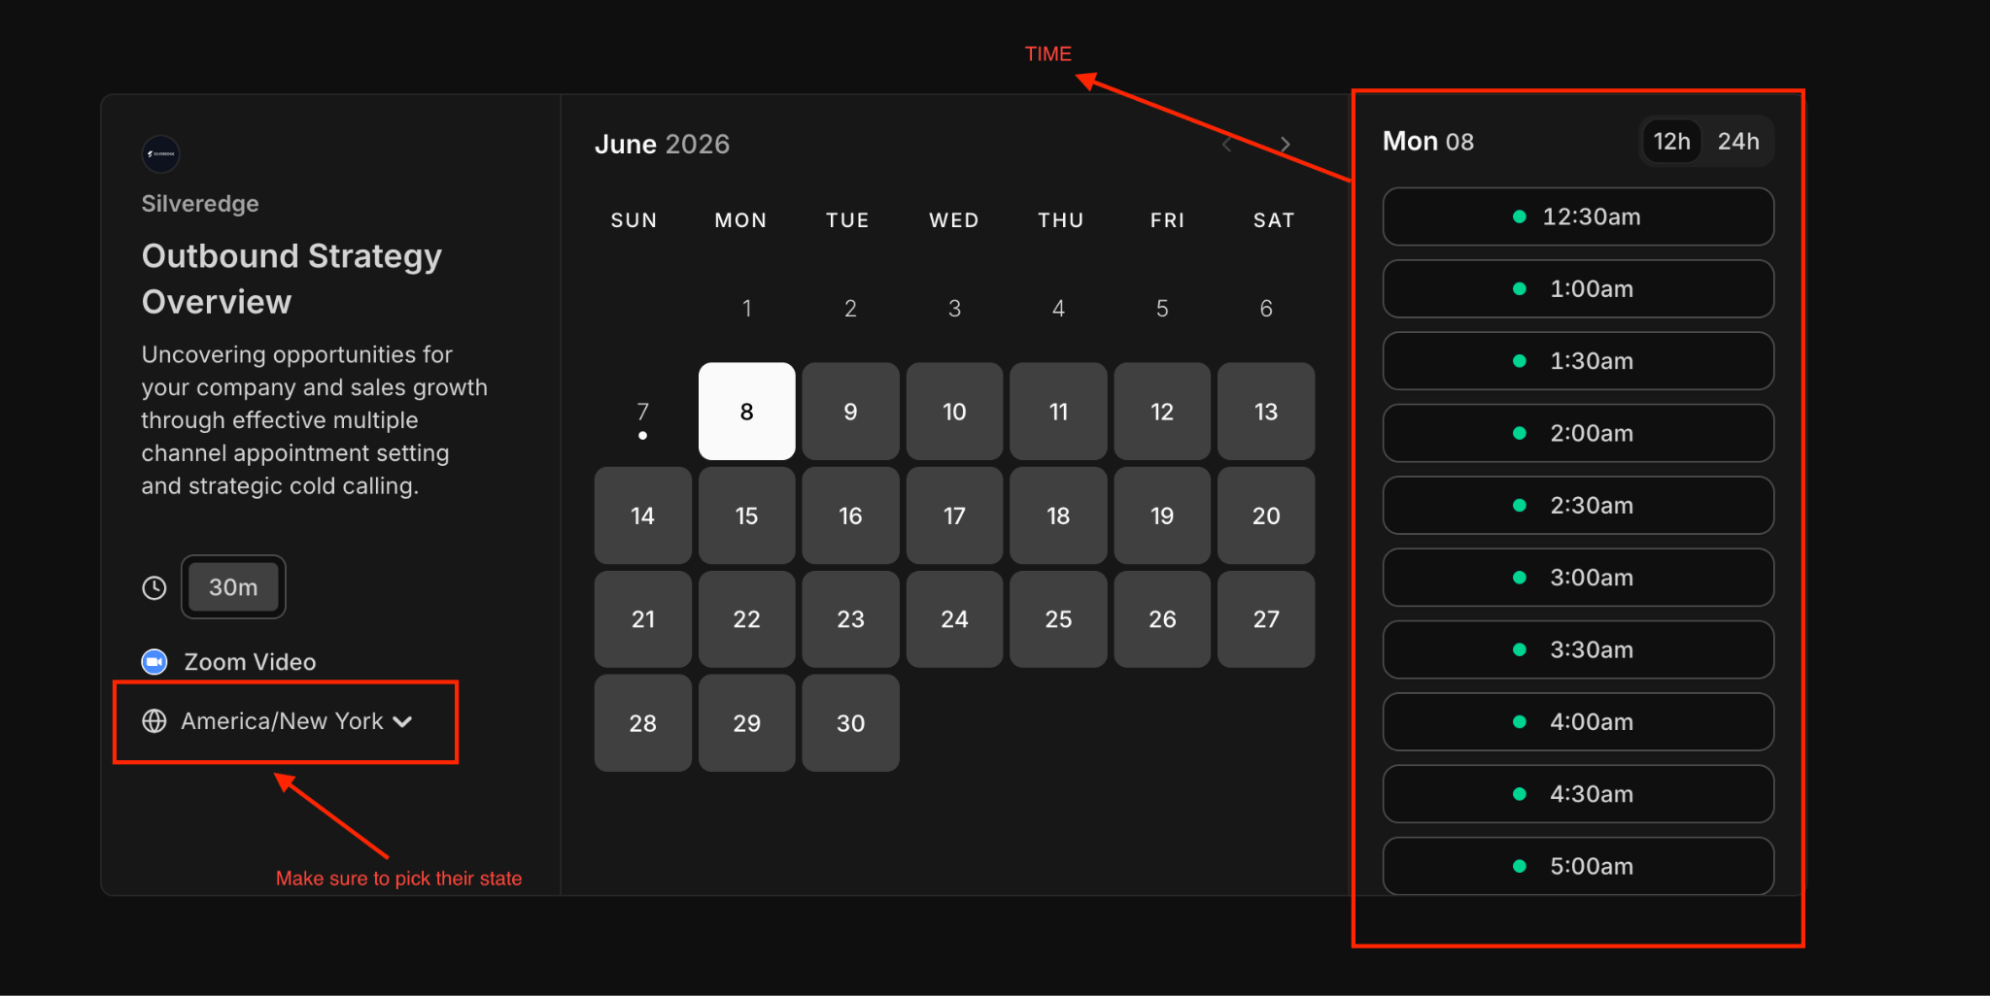

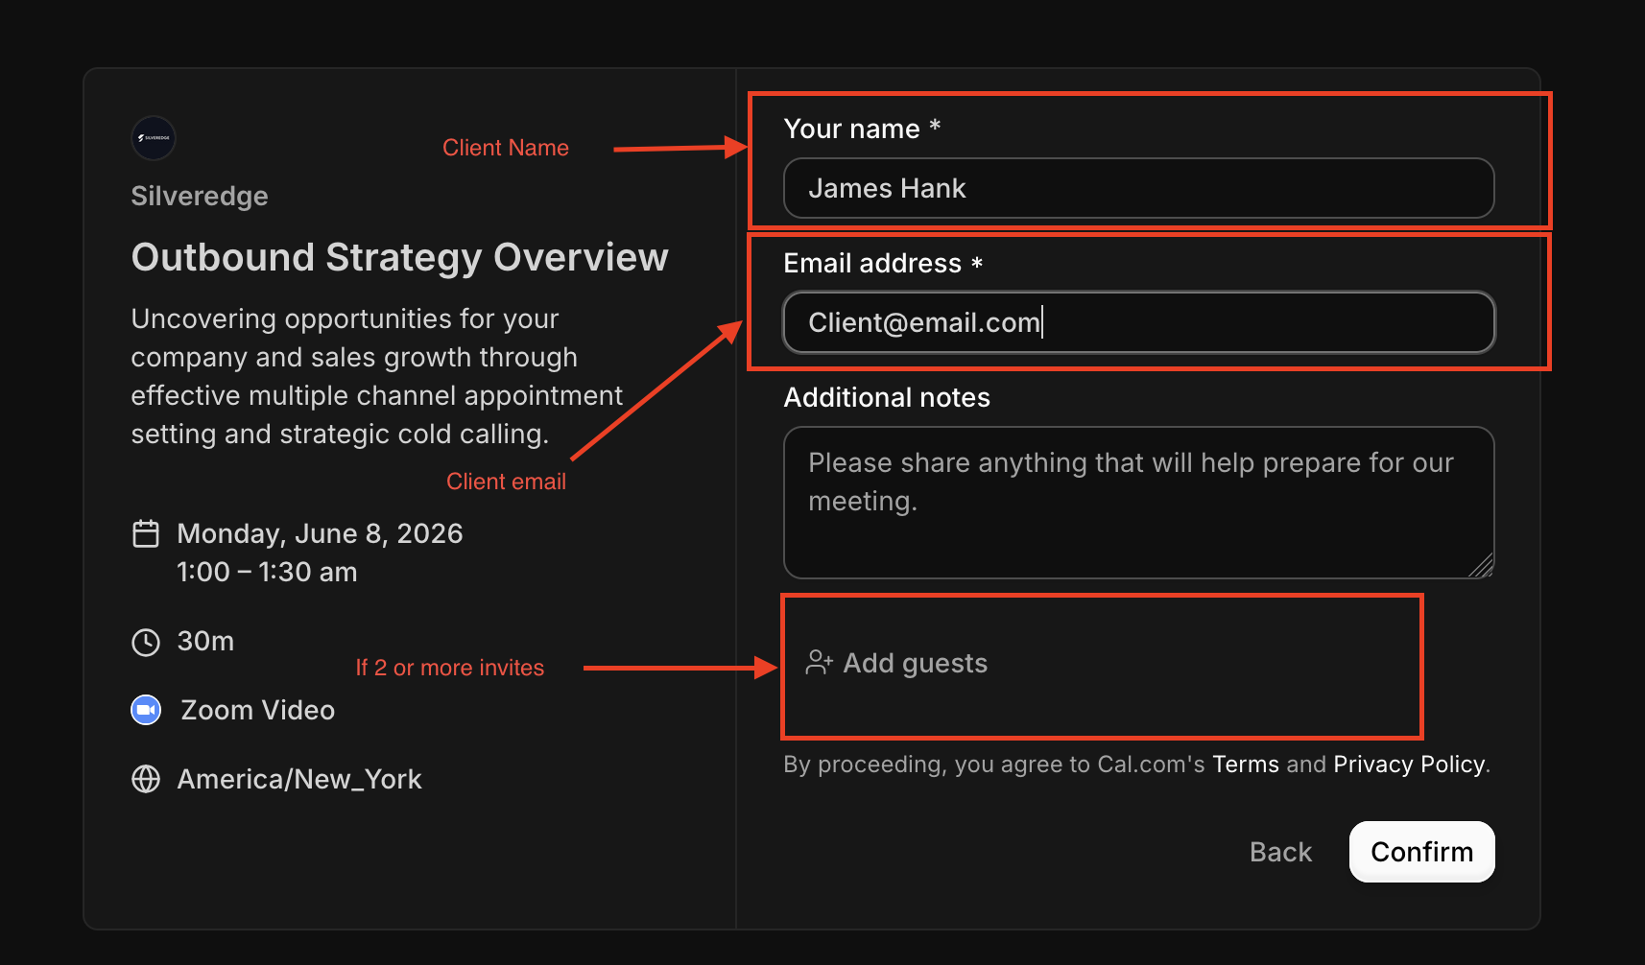

TIMEZONE DIFF
SOP
Audit Daily calls from yesterday
Audit Trello
Audit
Check did
Log DC
Logs and connect audit
Feedbacking
Audit DC’s

Create warming up cadence

New numbers

1st day no dial
2nd day 5 dial each number

